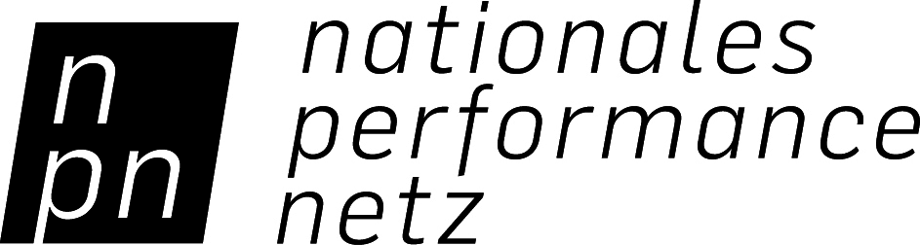

CREDIT STATEMENT

NPN INTERNATIONAL GUEST PERFORMANCE FUND FOR DANCE

PLEASE OBSERVE THESE GUIDELINES AND PASS THEM ON TO PRESS AND PUBLIC RELATIONS!

According to the Federal Government Commissioner for Culture and the Media (BKM) grant notice, the credits in publications (press reports, programs, evening programs, posters, flyers, websites, newsletters, etc.) for all guest performances abroad supported by the NPN International Guest Performance Fund for Dance must be written as follows:

“Supported by the NATIONALES PERFORMANCE NETZ International Guest Performance Fund for Dance, which is funded by the Federal Government Commissioner for Culture and the Media.“
+ [NPN logo]
+ [BKM logo]

The credit statement, with both logos, must be placed at a visible location. The correct listing in all publications (print and online) is an indispensable requirement for support and a part of the support contract. Abbreviations of this statement are not permitted! The credit statement and the logos must both always be listed.

The NPN credit statement and both logos can be downloaded at:

www.jointadventures.net/en/nationales-performance-netz/international-guest-performances/

