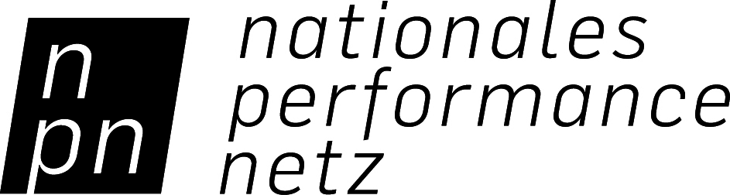

CREDIT STATEMENT

NPN COPRODUCTION FUND FOR DANCE

PLEASE NOTE THESE GUIDELINES AND PASS THEM ON TO PRESS AND PUBLIC RELATIONS!

According to the Federal Government Commissioner for Culture and the Media (BKM) grant notice, the credits in publications (press reports, programs, evening programs, posters, flyers, websites, newsletters, etc.) for all performances in Germany and abroad for productions supported by the NPN Coproduction Fund for Dance must be written as follows:

“Supported by the NATIONALES PERFORMANCE NETZ Coproduction Fund for Dance, which is funded by the Federal Government Commissioner for Culture and the Media.“
+ [NPN logo]
+ [BKM logo]

The credit statement, with both logos, must be placed at a visible location. The correct listing in all publications (print and online) is an indispensable requirement for support and a part of the support contract. Abbreviations of this statement are not permitted! The credit statement and the logos must both always be listed. Please do not confuse the credit statements for the NPN Coproduction Fund for Dance and the Guest Performance Fund for Dance.

The NPN credit statement and logos can be downloaded at:

www.jointadventures.net/en/nationales-performance-netz/dance-coproductions/

The applicant is responsible for ensuring that the credit statement and logo are published correctly by the respective programmers at all future guest performances and shows!

