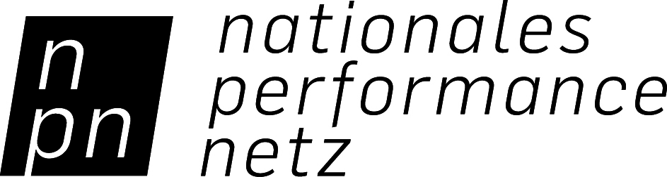

Source and disposition Statement
for the Co-production Fund for Dance

GRANT RECIPIENT (= Applicant/ CO-PRODUCER 1)
Name
Responsible
Address
Telephone
Fax
E-mail

Grant Project
Name of company/ artist
Title of the production
Date of project start
Venue and date of premiere

OBLIGATORY ADDENDA
- A signed cash-based accounting statement for the production from the beginning of rehearsals to the premiere, including a line-item listing or list of entries/ account distributions (online at: http://www.jointadventures.net/en/nationales-performance-netz/downloads.html).
- Copies of receipts and an overview of receipts that cover the expenditures at the level of the NPN subsidy granted per contract.
- Report: max. 1 DIN-A4 page.
- Proof of publication: 1 copy of each type of publication (program, evening program, poster, etc.).

I/ we ensure that the information included in the source and disposition statement are in accordance with the actual costs. The expenditures were necessary. The process was completed in an economical manner. I/ we can document all of the listed costs via original receipts. The original receipts can be examined in accordance with the grant contract. I/ we request that the grant sum be transferred to the account listed above.

Location , date

Legal signature/ s: _________________________ / _________________________

